CN LAB 3
Muhammad Hammad 24k-0544

TASK 1
Server
import socket
import json
from datetime import datetime
HOST = "127.0.0.1"
PORT = 5000
s_socket = socket.socket(socket.AF_INET, socket.SOCK_STREAM)
s_socket.bind((HOST, PORT))
s_socket.listen(5)
print("Server is running...")
print(f"Listening on {HOST}:{PORT}")
while True:

c_socket, c_addr = s_socket.accept()
print(f"\nClient connected: {c_addr}")
try:
data = c_socket.recv(1024).decode()
if not data:
c_socket.close()
continue
request = json.loads(data)
num1 = request["num1"]
num2 = request["num2"]
operation = request["operation"]
if operation == "+":
answer = num1 + num2
elif operation == "-":
answer = num1 - num2
elif operation == "*":
answer = num1 * num2
elif operation == "/":
if num2 == 0:
answer = "Cannot divide by zero"
else:
answer = num1 / num2
else:
answer = "Invalid operation"
record = {
"num1": num1,
"operation": operation,
"num2": num2,
"answer": answer,
"client_ip": c_addr[0],
"timestamp": datetime.now().strftime("%Y-%m-%d %H:%M:%S")
}
try:
with open("records.json", "r") as file:
calculations = json.load(file)
except (FileNotFoundError, json.JSONDecodeError):
calculations = []
calculations.append(record)
with open("records.json", "w") as file:
json.dump(calculations, file, indent=4)
response = str(answer)
c_socket.send(response.encode())
print(f"Received: {num1} {operation} {num2}")
print(f"Answer sent: {answer}")
print("Details saved to records.json")
except Exception as e:
c_socket.send(f"Error: {e}".encode())
c_socket.close()

Client

import socket
import json
HOST = "127.0.0.1"
PORT = 5000
while True:
try:
client_socket = socket.socket(socket.AF_INET, socket.SOCK_STREAM)
client_socket.connect((HOST, PORT))
print("\nConnected to server")
num1 = float(input("Enter first number: "))
num2 = float(input("Enter second number: "))
operation = input("Enter operation (+, -, *, /): ")
data = {
"num1": num1,
"operation": operation,
"num2": num2
}
message = json.dumps(data)
client_socket.send(message.encode())
response = client_socket.recv(1024).decode()
print("Result from server: ", response)
client_socket.close()
choice = input("\nDo another calculation(y/n): ")
if choice.lower() != "y":
print("Client closed.")
break
except Exception as e:
print("Error: ", e)
break
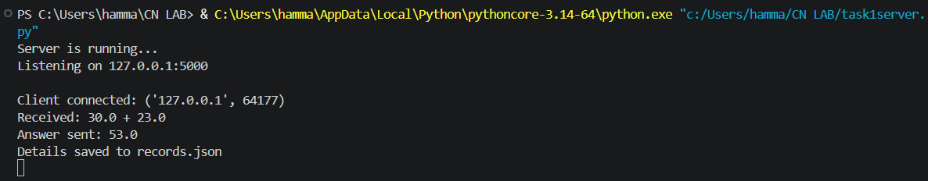
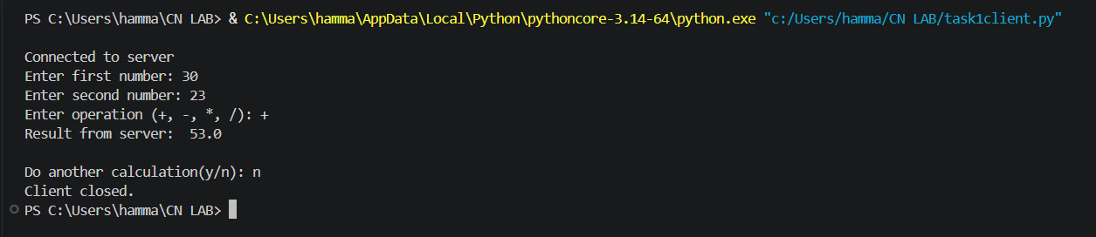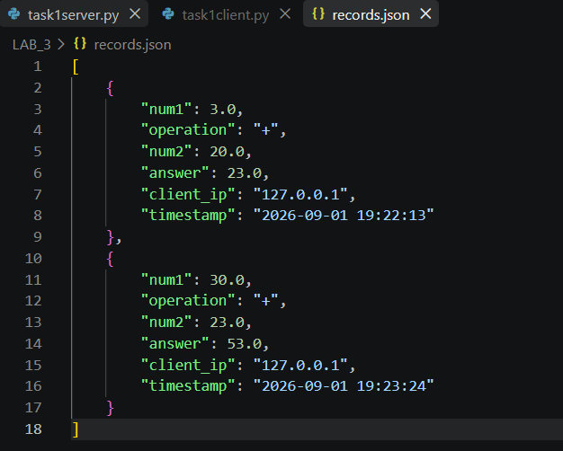
TASK 2
Server
import socket

HOST = "127.0.0.2"
PORT = 3000

server_socket = socket.socket(socket.AF_INET, socket.SOCK_STREAM)
server_socket.bind((HOST, PORT))

server_socket.listen(5)
print("Server is running...")

while True:
client_socket, client_address = server_socket.accept()
print(f"\nClient connected: {client_address}")

try:
data = client_socket.recv(1024).decode()
if not data:
client_socket.close()
continue

grade_points = float(data)
if grade_points >= 4.33:
letter_grade = "A+"
Qualitative_feedback = "Excellent"
elif grade_points >= 4.0:
letter_grade = "A"
Qualitative_feedback = "Excellent"
elif grade_points >= 3.66:
letter_grade = "A-"
Qualitative_feedback = "Very Good"
elif grade_points >= 3.33:
letter_grade = "B+"
Qualitative_feedback = "Very Good"
elif grade_points >= 3.0:
letter_grade = "B"
Qualitative_feedback = "Very Good"
elif grade_points >= 2.66:
letter_grade = "B-"
Qualitative_feedback = "Good"
elif grade_points >= 2.33:
letter_grade = "C+"
Qualitative_feedback = "Good"
elif grade_points >= 2.0:
letter_grade = "C"
Qualitative_feedback = "Good"
elif grade_points >= 1.66:
letter_grade = "C-"
Qualitative_feedback = "Passable"
elif grade_points >= 1.33:
letter_grade = "D+"
Qualitative_feedback = "Passable"
elif grade_points >= 1.0:
letter_grade = "D"
Qualitative_feedback = "Passable"
else:
letter_grade = "E"
Qualitative_feedback = "Failure"

response = f"Your letter grade is: {letter_grade}\nQualitative feedback: {Qualitative_feedback}"
client_socket.send(response.encode())
print(f"Received grade points: {grade_points}")
print(f"Letter grade sent: {letter_grade}")
print(f"Qualitative feedback sent: {Qualitative_feedback}")

except Exception as e:
client_socket.send(f"Error: {e}".encode())

client_socket.close()

Client
import socket

HOST = "127.0.0.2"
PORT = 3000

client_socket = socket.socket(socket.AF_INET, socket.SOCK_STREAM)
while True:
try:
client_socket.connect((HOST, PORT))
print("\nConnected to server")
grade = input("Enter your grade points: ")
client_socket.send(grade.encode())
response = client_socket.recv(1024).decode()
print("Result from server: ", response)
break
except Exception as e:
print("Error: ", e)
break
